1. 90% hands-on and 10% theory.
2. What is redis?  
   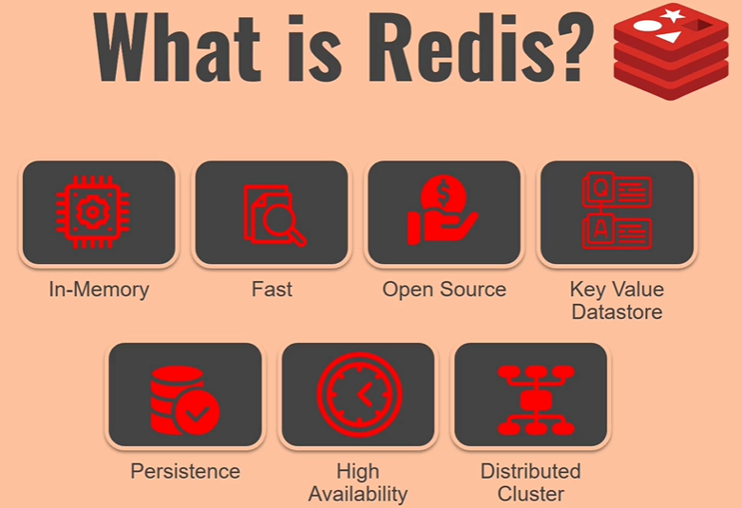
   1. **In-memory** Redis is in-memory DB. It so fast as reading and writing into the main memory is huge **fast** as compared to reading and writing into hard disk. It’ actually almost 10,000 times fast.
   2. **Fast**: It’s also very fast as compared to other in-memory DBs as it’s written in **C language** which is very close to machine.
   3. **Open Source**: No cost.
   4. **Key Value Datastore**: Whatever data we store in redis is in key-value pairs. So it’s more like a **dictionary**. Redis is **key-value Data Store**.
   5. **Persistence**:
      1. When Redis starts, it loads data from Hard-Disk.
      2. All operations (read/write) are performed on data in memory.
      3. Snapshots of the dataset are stored in Hard-Disk as Dump and trigger time can be configured.
      4. Yes, data is **durable**. It provides **durability**.
   6. **High Availability:** Redis gives you option of **high availability** as there are many ways to set up for this. If you setup **3 servers** and one of them **goes down**, then redis is going to be fully functional and your app is not going to get impacted from redis not being available.
   7. **Scalability**: **Distributed Cluster**: If you set up a redis cluster with six servers and in future you want to increase the number of servers to gain more out of redis, you can do that by scaling up.
3. The Good thing is that configuring all of those things are very easy but if you want to do the same thing using any other datastore technology. Redis is great simple.
4. Let’s understand some of the things in more detail. So when we said that this is in memory.  
   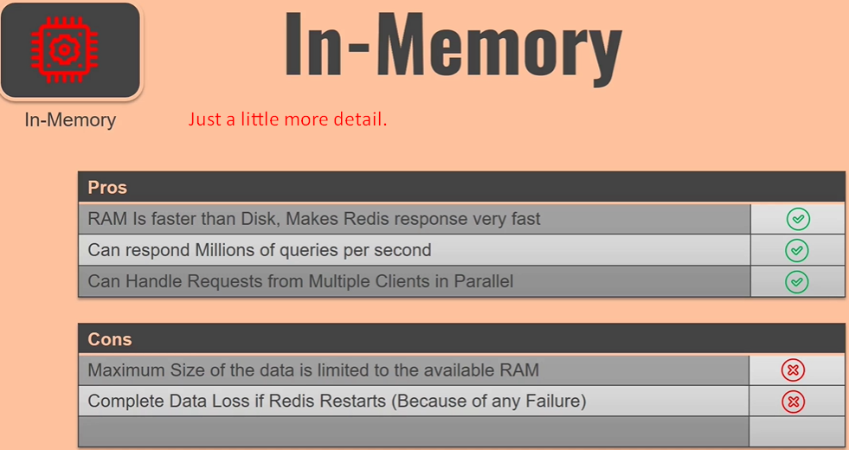
5. 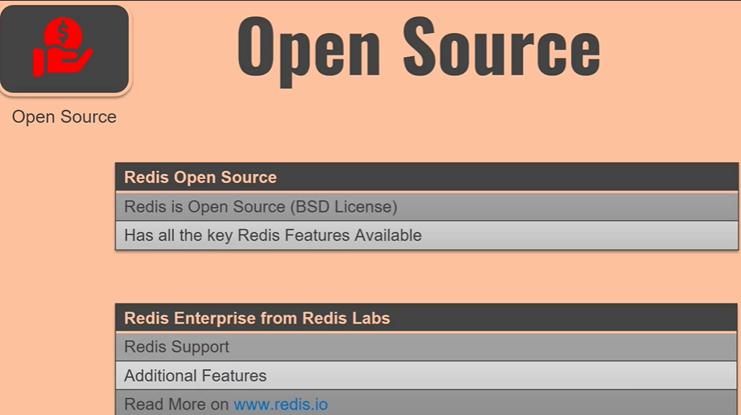
6. 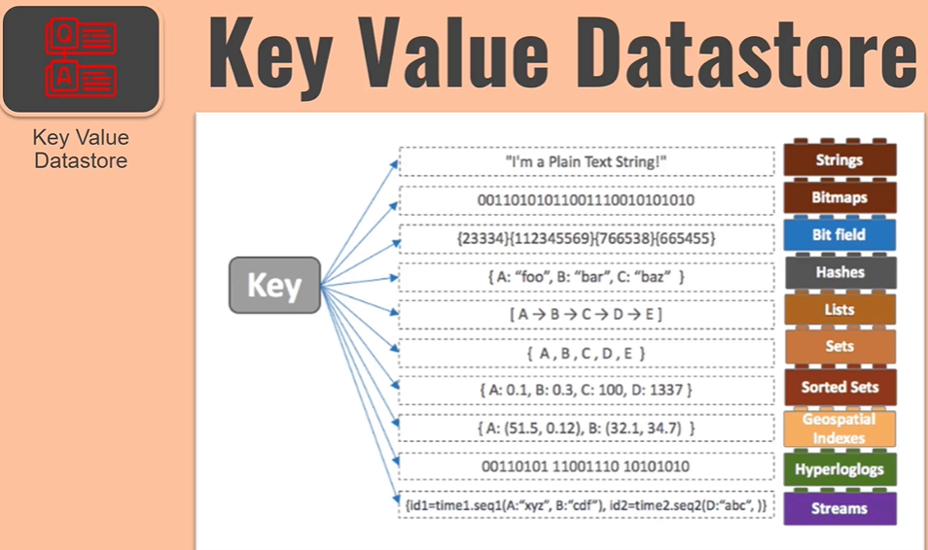
7. 